**Exp. No : 2**

**Word Count Map Reduce program**

1. Create word_count.txt file

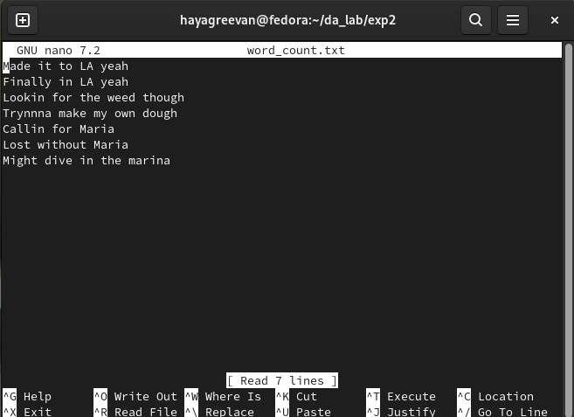

1. Create mapper.py program

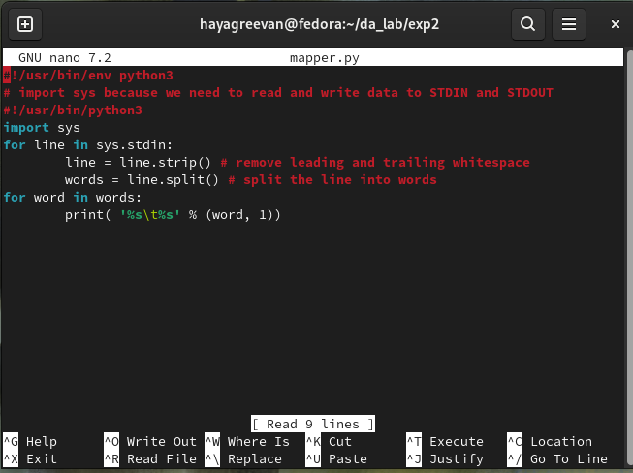

1. Create reducer.py program.

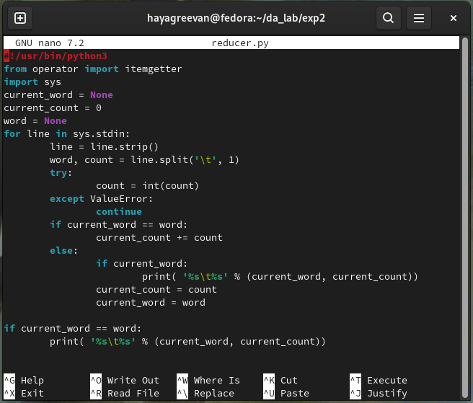

1. Storing the word_count.txt in HDFS Storage.

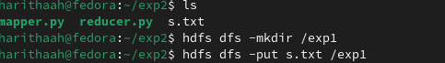

1. Running the Word Count program using Hadoop Streaming.

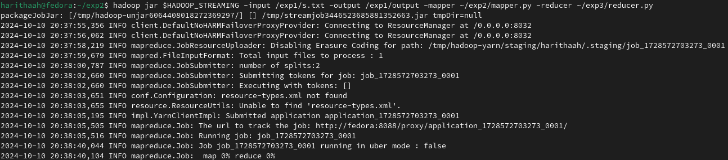

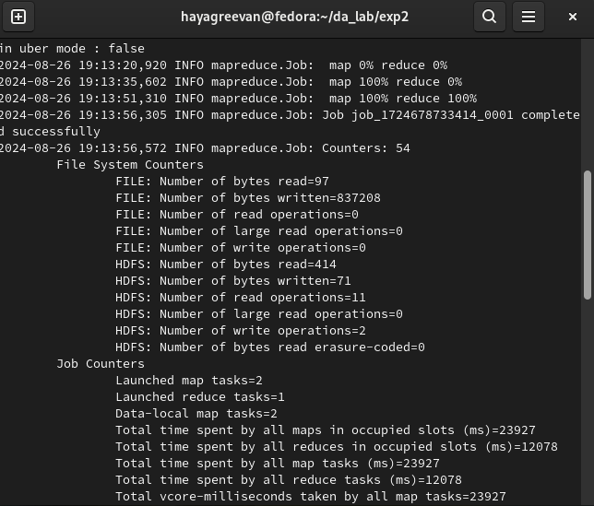

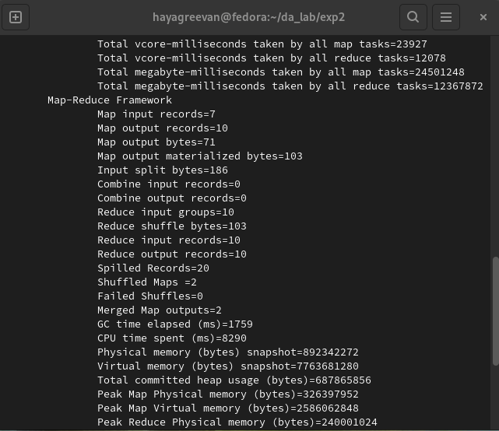

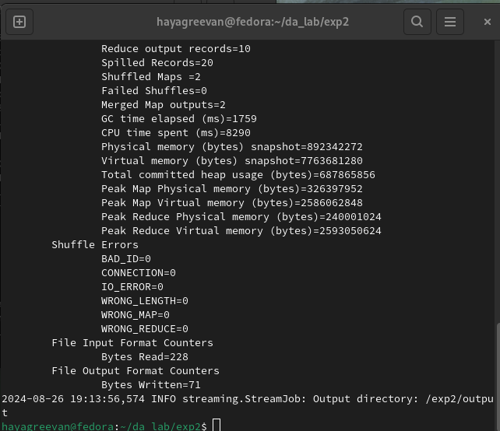

**Output :**

